**INDIAN INSTITUTE OF TECHNOLOGY, KANPUR**



**SURGE 2022**

**PROJECT REPORT**

**Using a restless bandit game to investigate whether there is a link between schizotypy and decision-making in dynamically changing environments.**

**SUBMITTED BY**

**Sanika Gumaste**

**SURGE No.: 2230108**

**Roll No.: 200865**

**Department Of Electrical Engineering**

**Under the Guidance of**

**Prof. ARJUN RAMAKRISHNAN and HARSH ARORA**

**Department of Biological Science and BioEngineering**

**IIT Kanpur**

**CONTENTS**

Content Page No.

1. Abstract 3
2. Introduction 4
3. Literature Review 5
4. Data Processing 7
5. Data Analysis 9
6. Summary 12
7. References 13

**ABSTRACT**

Belief updating or the changing of one’s beliefs in response to dynamic environments can prove to be an essential biological marker in tracking down mental health illnesses. In this project, we will be looking at schizotypy, a theoretical concept that is related to extreme states of mind, especially schizophrenia. To assess the correlation between belief updating and schizotypy, we have used a restless four-arm bandit game with corresponding pre-filled survey results. The four-arm game consists of four slot machines with varying rewards changing according to parameters such as volatility and block, which the participant can choose between, in order to maximize the rewards gained. The game helps us determine the belief updating of the participants using analytical parameters such as advantageous choices and switching options, using variables such as the maximum and minimum rewards, and the difference between these two.

**INTRODUCTION**

Belief updating is changing or ‘updating’ our beliefs in response to our changing surroundings. In recent times, has proven to be a biological marker in assessing mental health. Studying the mechanism for belief updating can provide useful insights into mental disorders and can also help develop better practices for diagnosis.

In this project, we will be using a computer-based restless four-arm bandit game to assess the decisions made by healthy young adults. It would require participants to update their beliefs during the gameplay to make optimal decisions rapidly. We will analyze these changes in decisions using computational models.

We will also ask the participants to fill out surveys to determine their schizotypy scores. Later, we will compare the restless bandit scores with the pre-filled survey results.

This can help us to account for how likely a person is to develop a mental condition like schizotypy in its earlier stages, and how that reflects on the behavioral account during the decision made while playing the game. This can help us detect the onset of schizophrenia in healthy young adults.

**LITERATURE REVIEW**

* Belief updating: The response to changing stimuli can help us study the adaptability, willingness to change, and grasping power of a person, which can provide valuable insights into mental disorders and can also help develop better practices for diagnosis.
* Four arm bandit game  
  This is a game in which a person must choose between multiple options, each with an unknown reward. The goal is to determine the best or most profitable outcome through a series of choices.

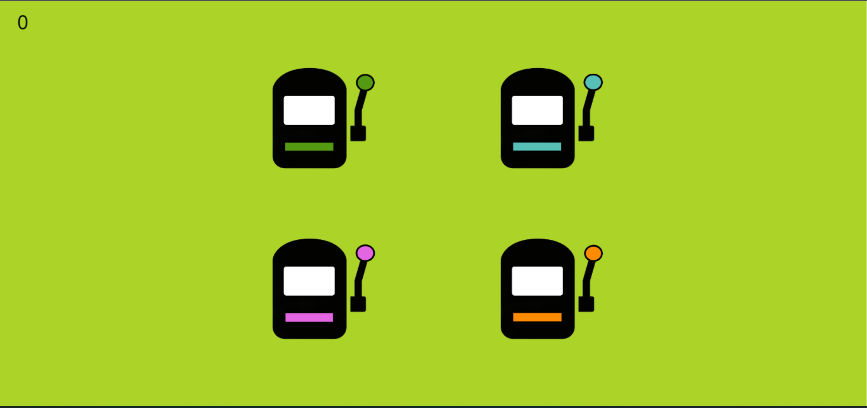

In our game, we will be using 4 sets of games of 50 moves each.

* Types of models in the game  
  The rewards of the slot machines changes after every selection, giving us 4 sections based on the following factors:
  + Block - A block simply tells us if we’re using a ‘loss’ or ‘no loss’ block - the block will be decided based on a coin flip

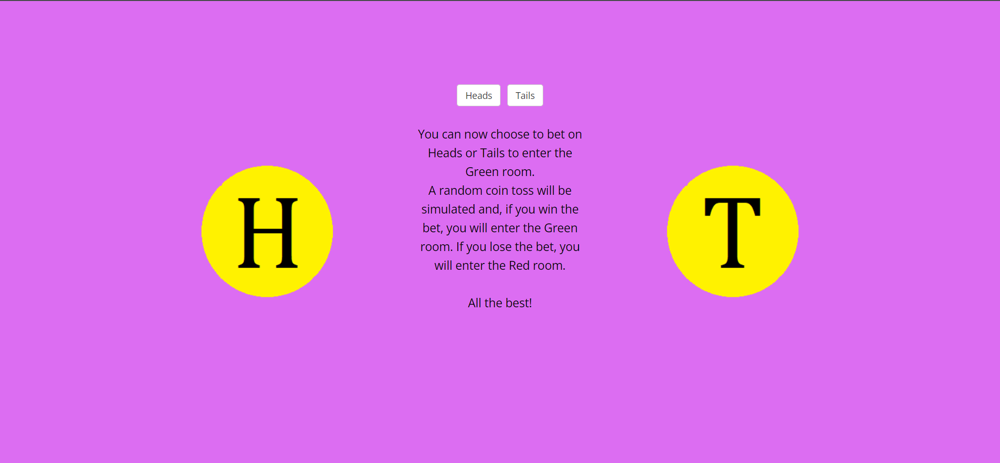.

* + Volatility - Volatility tells us how much the rewards change after every decision. We deal with two types of volatility - high and low

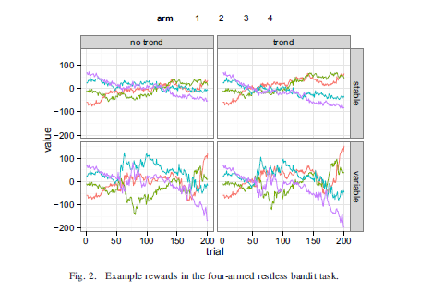

* + Trend - In this type of variation, we set a trend for the rewards, it either increases, decreases, or remains constant.

In this project, we will not look at the variation of rewards with respect to the trend. Thus, we will be working on 4 sections of the game

* Schizotypy  
  Schizotypy is a theoretical concept that posits a continuum of personality characteristics and experiences, ranging from normal dissociative, imaginative states to extreme states of mind related to psychosis, especially schizophrenia.

Schizophrenia is a serious mental disorder in which people interpret reality abnormally. It may result in some combination of hallucinations, delusions, and extremely disordered thinking and behavior that impairs daily functioning, and can be disabling.

There are three types of symptoms related to schizophrenia -   
 Positive symptoms - Hallucinations, delusions, and disorganized speech and thoughts  
 Negative symptoms - Apathy and withdrawal  
 Cognitive symptoms - Memory issues, inability to decide and process social cues

**DATA PROCESSING**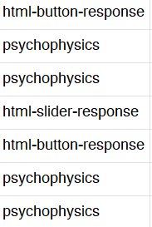

* Understanding the Raw Data  
  The raw data consists of three types of data
  + The choices made by the participants
  + Stress slider
  + HTML change button

Each row contains multiple columns of data such as

* + run_id
  + Trial_type and index
  + Stimulus - the message on the screen
  + Response_type
  + stress
  + block_no
  + cum_reward
  + arm_values

Barring that, there is a lot of unwanted data in the raw sheet.

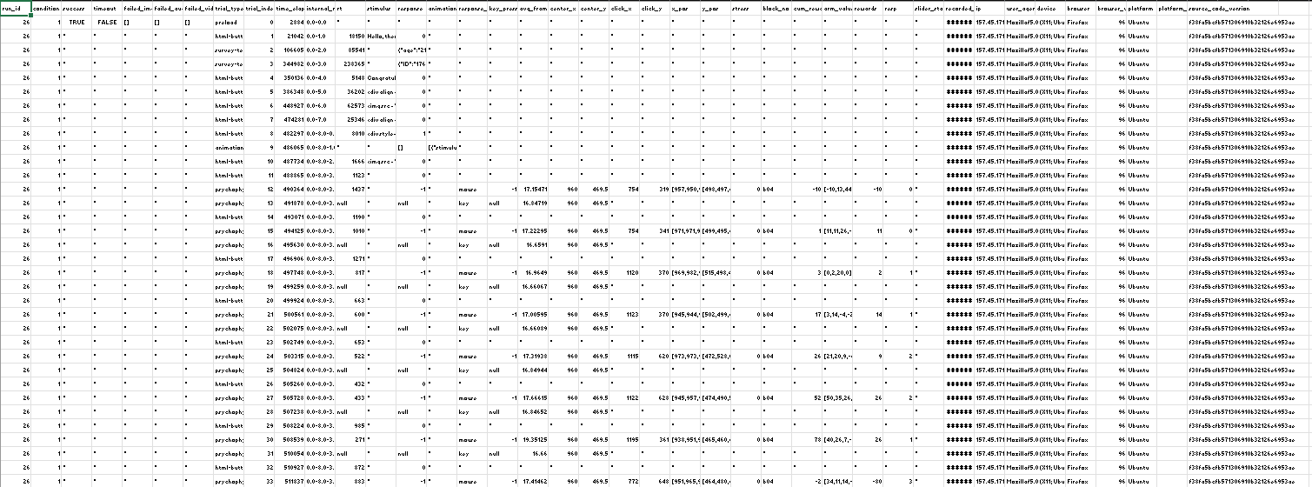

* Preprocessing the data  
  The data is processed using the R language. The raw data also consists of a lot of irrelevant data. We need to process this data to provide valuable bits of information such as the run id, the stress slider, the block number, and the slot machine chosen.

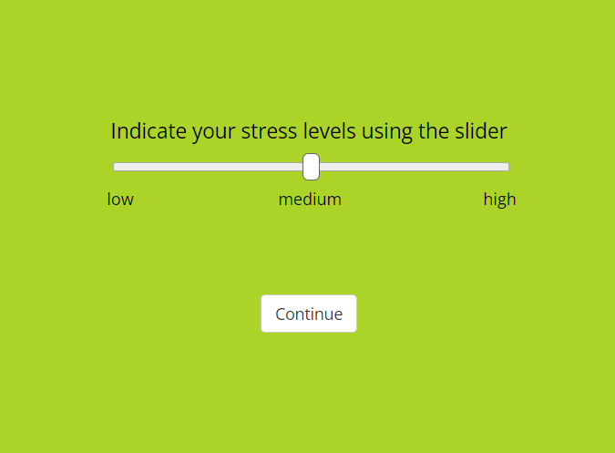

* Processed data  
  We need to filter out the data that is redundant. We need to remove the rows which do not have a stress value. There are essentially the rows that contain the HTML buttons and other irrelevant values. At the end of the code, we write a new CSV with the filtered data, with only the relevant columns (stress, block_no, block, trial_no, choice, if advantageous, switch, reward, cum_reward, and the newly introduced variables)

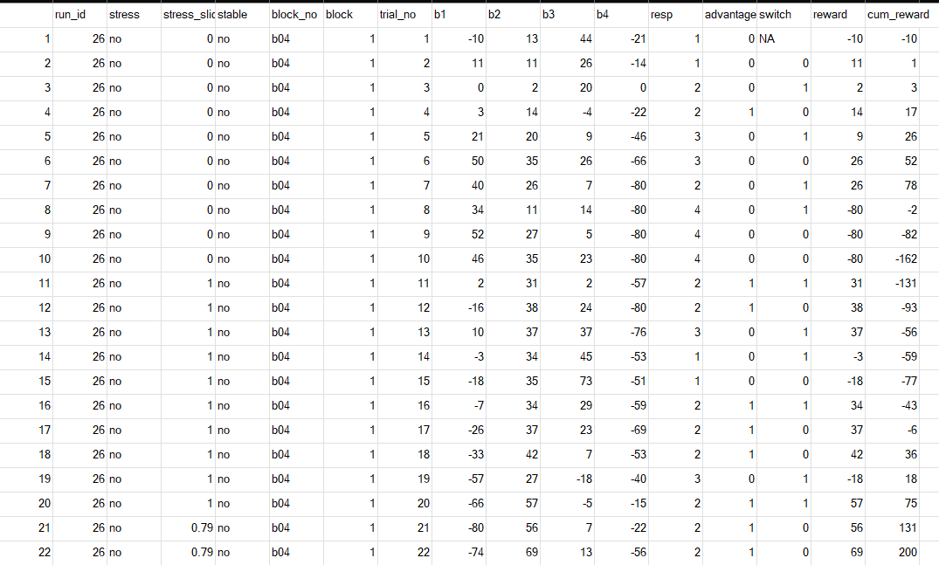

* Analytical Variables  
  The data needs to be analyzed based on the advantageous choices and the switching behavior of the participants. To analyze these choices we use different variables involving the reward values such as max, min, diff, etc. More such variables need to be suggested.
* Parameters  
  The data is analyzed based on the two parameters mentioned above. We need to add to these parameters that can also be used to measure the schizotypy scores of the participants.

**DATA ANALYSIS**

* **Pre-Processing Code**
  + We need to process the data in the raw sheets z  
    Firstly, we need to filter out the redundant data. We need to remove the rows which do not have a stress value. There are essentially the rows that contain the HTML buttons and other irrelevant values.
  + Outliers:  
    We implement a function called *outliers* which essentially checks if the reward generated by the player is less than 2.5 times that of a random agent. If yes, then that reading is considered an outlier.
  + The final CSV  
    At the end of the code, we write a new CSV with the filtered data, with only the relevant columns (stress, block_no, block, trial_no, choice, if advantageous, switch, reward, cum_reward, and the newly introduced variables)
  + Additionally, this code also filters and ‘polishes’ the data in the raw CSV
* **Advantageous choices**
  + Pairs.panels  
    Plots one variable against two variables and the diagonal elements show the variation of the first variable
  + GLMM - Generalised linear mixed models
    - Generalized linear - non-normal distribution
    - Mixed effect - multiple sources of random error
    - Used when the outcome is not related linearly, but some function of the outcome is
      * It uses combinations of variables to plot different analytical models
      * For example: model1 <- buildGLMMadaptive(advantageous ~ stress*stable + scale(avg) + scale(max1) + trial_no + (1 | run_id), family = binomial, data = main_df)
      * Here, in multiple models, we change one variable, scale() - scale(max1) is replaced by scale(diff1), scale(diff2), etc.
* GLMM
  + Every model has a different number and combinations of variables that the model chooses to give an optimum model
  + There are 8 models, model1-model8 having the same set of variables (except for 1)
  + There are 8 more models in which there is another set of variables used for modeling

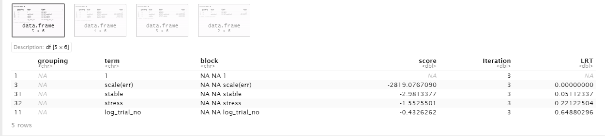

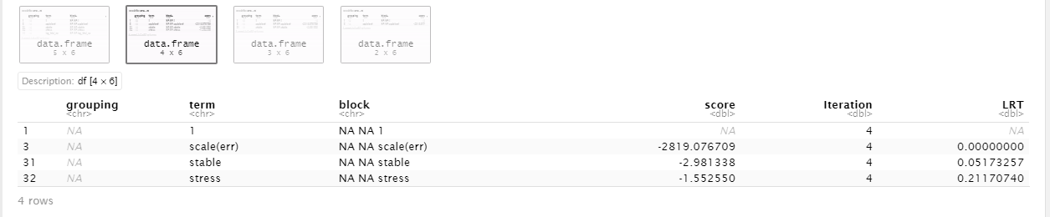

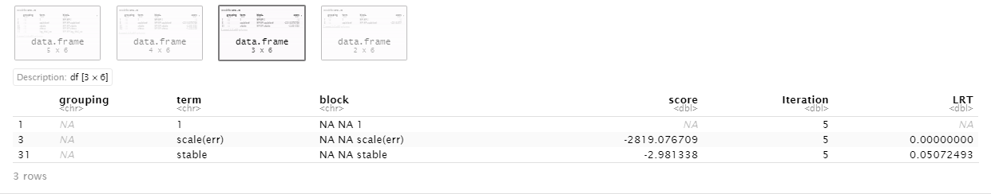

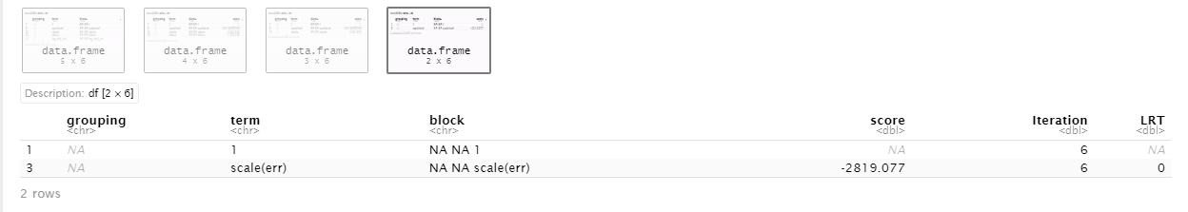

**Best Model Estimates**

* Completion:
  + We take the processed data and check every row. If the data is incomplete, then that row is not considered in the analysis.
* Repetitions
  + We look at two variables at a time and if there is a high correlation then we do not take that combination in a single model. We segregate them.
* The code uses lasso regression to find out the best model to analyze the data
  + Lasso regression - lasso is a regression analysis method that performs both variable selection and regularization to enhance the prediction accuracy and interpretability of the resulting statistical model

**SUMMARY**

Belief updating can prove to be an essential biological marker in tracking down mental health illnesses. To assess this, we have used a restless four-arm bandit game with corresponding survey results to assess the correlation between schizotypy and decision-making in dynamic environments

The four-arm game consists of four slot machines with varying rewards that the participant can choose between, to maximize the rewards gained

The game helps us determine the belief updating of the participants using analytical parameters such as advantageous choices and switching options, using variables such as the maximum and minimum rewards, and the difference between these two

We wish to find a link between the analytical parameters and the survey results.

The desirable conclusion that one would expect out of this experiment can be presented by evaluating every one of the four sets of 50 choices each, in which the participant plays the game.

1. Positive and highly volatile
2. Positive and stable
3. Negative and highly volatile
4. Negative and stable

We can assess the sets based on the parameters - switching between the choices, choosing the most advantageous choice, and the stress levels indicated by the participant.

1. Positive and highly volatile - In this set, one would expect the participant to have low to moderate stress values. We could expect a more explorative approach pertaining to the higher volatility, however, the participant should be able to stick to the most advantageous choice by the end of the set.
2. Positive and stable - Here, we would expect the participant to have the least stress values. The participant should be able to stick to the most advantageous choices faster than the previous set. As the reward values are also stable, we expect a better turn out of rewards in this set.
3. Negative and highly volatile - In this set, one would expect the participant to have the highest stress values. Here, we expect the least explorative approach as the participant would like to stick to the slot machines that have a higher probability of providing higher rewards, weighing in the risk factor.
4. Negative and stable - In this set, we could see a lesser stress value as compared to the previous set. One should be able to find out the most advantageous choice of the slot machines by the end of the set.

In general, extreme switching could indicate uncertainty and instability of the participant’s decision-making, whereas minimal switching could indicate subpar belief updating in the participants. The choosing of advantageous choices can be analyzed on the basis of volatility and block. If the person is playing uncautiously in negative blocks, then it could be a negative indicator. Similarly, minimal risks taken in the positive block could be problematic too.

The highly volatile and negative block expects the participant to experience higher levels of stress than usual. Whereas the other two expect a lower stress level. Any result/collection of results that deviate from these predictions could indicate some symptom or indicator of schizotypy.

**REFERENCES**

1. U[ncertainty and exploration in a restless bandit problem](https://decisionlabv30.slack.com/files/U03FXPWQW4W/F03HL52BX8S/marteen_uncertainty_and_exploration_in_a_restless_bandit_problem.pdf) - by Maarten Speekenbrink, and Emmanouil Konstantinidis
2. A Primer on Foraging and the Explore/Exploit Trade-Off for Psychiatry Research - by MA Addicott, JM Pearson2, MM Sweitzer, DL Barack, and ML Platt
3. [The misestimation of](https://decisionlabv30.slack.com/files/U03FXPWQW4W/F03HH7H3529/the_misestimation_of_uncertainity.pdf) uncertainty - by Erdem Pulcu1 and Michael Browning
4. Decision-Making under Stress in Volatile Environments - by Pratham Shukla, Harsh Arora, Dr. Ashutosh Modi, and Dr. Arjun Ramakrishnan
5. Decision-Making Under Stress in Volatile Environments - by Pratham Shukla
6. [Champman’s magical ideation](https://decisionlabv30.slack.com/files/U03FXPWQW4W/F03JDS30PTL/champman_s_magical_ideation.pdf) - by Mark Eckblad and Loren J. Chapman
7. Understanding Learning Through Uncertainty and Bias - by [Rasmus Bruckner](https://osf.io/fxhjb/), Hauke R. Heekeren, and Matthew R. Nassa